Monday | Tuesday | Wednesday | Thursday | Friday
4  CEREAL CUPS  CHEESE STICKS  FRUIT  JUICE/MILK | 5  STRAWBERRY PANCAKES  YOGURT  FRUIT  JUICE/MILK | 6  FRENCH TOAST  CHEESE STICKS  FRUIT  JUICE/MILK | 7  FRUIT FRUDELS  YOGURT  FRUIT  JUICE/MILK | 8  NO  SCHOOL
11  BREAKFAST PIZZA  YOGURT  FRUIT  JUICE/MILK | 12  BANANA MUFFINS  YOGURT  FRUIT  JUICE/MILK | 13  CEREAL CUPS  CHEESE STICKS  FRUIT  JUICE/MILK | 14  TOAST W/ PEANUT BUTTER OR JELLY  CHEESE STICKS  FRUIT  JUICE/MILK | 15  NO  SCHOOL
18  BREAKFAST BURRITOS  CHEESE STICKS  FRUIT  JUICE/MILK | 19  CEREAL CUPS  YOGURT  FRUIT  JUICE/MILK | 20  BREAKFAST ON A STICK  YOGURT  FRUIT  JUICE/MILK | 21  CEREAL BARS  CHEESE STICKS  FRUIT  JUICE/MILK | 22  NO  SCHOOL
25  CEREAL CUPS  CHEESE STICK  FRUIT  JUICE/MILK | 26  BREAKFAST SANDWICH  CHEESE STICK  FRUIT  JUICE/MILK | 27  THANKSGIVING  VACATION | 28  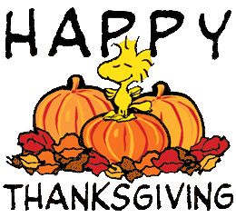 | 29  NO  SCHOOL
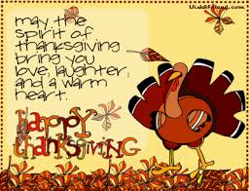 |  | 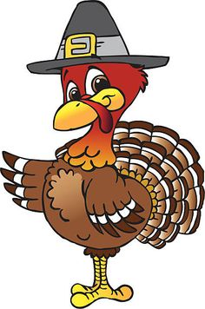
FREE & REDUCED MEALS: NEW APPLICATIONS MUST BE COMPLETED EACH YEAR. APPLICATIONS ARE AVAILABLE AT EACH SCHOOL OFFICE AND THE LUNCHROOM OFFICE. LUNCHCOST: Elementary, Middle & High School - $2.65, if qualified for reduced, .40 cents. Adults- $3.95. Breakfast is FREE for Students.
Monday | Tuesday | Wednesday | Thursday | Friday
4  PEPPERONI STUFFWICH  FRENCH FRIES  BROCCOLI  APPLES  MILK | 5  ORANGE CHICKEN  BROWN RICE  MIXED VEGGIES  MANDARIN ORANGES  MILK | 6  SPAGHETTI W/ MEATBALLS  GREEN SALAD  GOLD FISH CRACKERS  PEARS  MILK | 7  TOMATO SOUP  GRILLED CHEESE SANDWICH  BABY CARROTS  PEACH CUP  MILK | 8  NO  SCHOOL
11  PB&J SANDWICHES  DORITOS  FRUIT CUP  BABY CARROTS  MILK  Happy Veteran’s Day  Thank you for serving! | 12  CHEESEBURGERS W/WG BUN  TATER TOTS  TOMATO & ONION SLICES  APPLESAUCE  MILK | 13  CHICKEN CAESAR SALAD  GARLIC BREADSTICK  GARBANZO BEANS  BANANAS  MILK | 14  KFC BOWL  SOFT PRETZELS  PEAR CUPS  MILK | 15  NO  SCHOOL
18  CHICKEN STRIPS  CHEESY BREAD STICKS  SLICED CUCUMBERS  STRAWBERRY APPLESAUCE  MILK | 19  CORN DOGS  TWISTER FRIES  BABY CARROTS  ORANGES  MILK | 20  PIZZA  GREEN SALAD  PEAS  PINEAPPLE  MILK | 21  THANKSGIVING  DAY  DINNER!!  YUM-OH!! | 22  NO  SCHOOL
25  HAM & CHEESE POCKETS  WAFFLE FRIES  MIXED VEGGIES  FROZEN STRAWBERRIES  MILK | 26  BURRITOS  SPANISH RICE  SALSA/SOUR CREAM  FROZEN YOGURT  COOKIES!!  MILK | 27  THANKSGIVING  VACATION! | 28  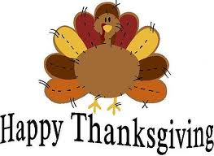 | 29  NO  SCHOOL
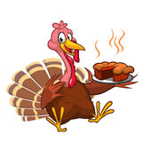 | HAVE A SAFE & HAPPY THANKSGIVING! | 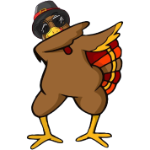 | 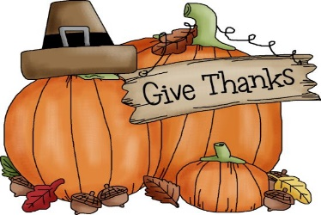 | 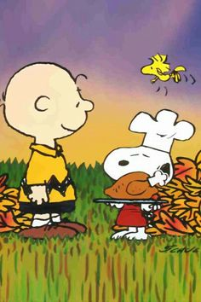
FREE & REDUCED MEALS: NEW APPLICATIONS MUST BE COMPLETED EACH YEAR. APPLICATIONS ARE AVAILABLE AT EACH SCHOOL OFFICE AND THE LUNCHROOM OFFICE. LUNCHCOST: Elementary, Middle & High School - $2.65, if qualified for reduced, .40 cents. Adults- $3.95.

